|  |  |  |  |  |  |  |  |  |  |  |  |
| --- | --- | --- | --- | --- | --- | --- | --- | --- | --- | --- | --- |
|  | | **Hope Foundation’s**  **Finolex Academy of Management and Technology, Ratnagiri** | | | | | | | | | |
| **Information Technology Department** | | | | | | | | | |
| Subject name: Big Data Analytics | | | | | | | | Subject Code: ITL801 | | | |
| Class | | BE IT | | Semester – VIII (CBGS) | | | | Academic year: 2019-20 | | | |
| Name of Student | | **Kazi Jawwad A Rahim** | | | | | **QUIZ Score :** | | | | |
| Roll No | | **28** | | | Assignment/Experiment No. | | | | | 03 | |
| **Title:**  **Creating graph database on Neo4j and displaying the relationships of graph.** | | | | | | | | | | | |
| **1. Course objectives applicable**  COB3.Understand various concepts of finding similar items and mining data streams  COB4.Study Page Rank in Link Analysis and concepts of Handling larger datasets  COB5.Study various clustering algorithms and Recommendation systems. | | | | | | | | | | | |
| **2. Course outcomes applicable:**  CO3 -Interpret business models and scientific computing paradigms, and apply software tools for big data analytics  CO4-Implement use of combiners to consolidate results and ability to handle larger datasets. | | | | | | | | | | | |
| **3. Learning Objectives:**   1. Understand the Neo4j Database application domain 2. Install and run Neo4j on the machine 3. Create graph database and display the relations of graph 4. Analyze the queries for creating relationship between nodes | | | | | | | | | | | |
| **4. Practical applications of the assignment/experiment: Neo4J is a graph Database, used in relationship based analysis on social networks** | | | | | | | | | | | |
| **5. Prerequisites**:   1. Knowledge of SQL 2. Knowledge of Graph Databases | | | | | | | | | | | |
| **6. Hardware Requirements**:   1. PC with 4GB RAM, 500GB HDD   **7. Software Requirements:**   1. Access to Neo4j Sandbox 2. Google chrome version 6.23 or higher | | | | | | | | | | | |
| **8. Quiz Questions (if any): (Online Exam will be taken separately batchwise, attach the certificate/ Marks obtained)**   1. What is a Graph Database? 2. Which Query language does graph database use? 3. Can you install Neo4J on windows? If yes, explain the process. 4. What relations were plotted on the console ? | | | | | | | | | | | |
| **9. Experiment/Assignment Evaluation:** | | | | | | | | | | | |
| **Sr. No.** | **Parameters** | | | | | | | | **Marks obtained** | | **Out of** |
| **1** | Technical Understanding (Assessment may be done based on Q & A **or** any other relevant method.) Teacher should mention the other method used - | | | | | | | |  | | 6 |
| **2** | Neatness/presentation | | | | | | | |  | | 2 |
| **3** | Punctuality | | | | | | | |  | | 2 |
| **Date of performance (DOP)** | | |  | | | **Total marks obtained** | | |  | | **10** |
| **Date of checking (DOC)** | | |  | | | **Signature of teacher** | | | | | |

**2. Precautions** :

1. Register on Neo4J first,
2. Request for crating sandbox, it will take time

**3. Installation Steps / Performance Steps -**

1. Sign in to Neo4j Sandbox installer.
2. Run the cypher queries
3. View the database relationships:
4. NoSQL Graph database Neo4j (The Movie graph)

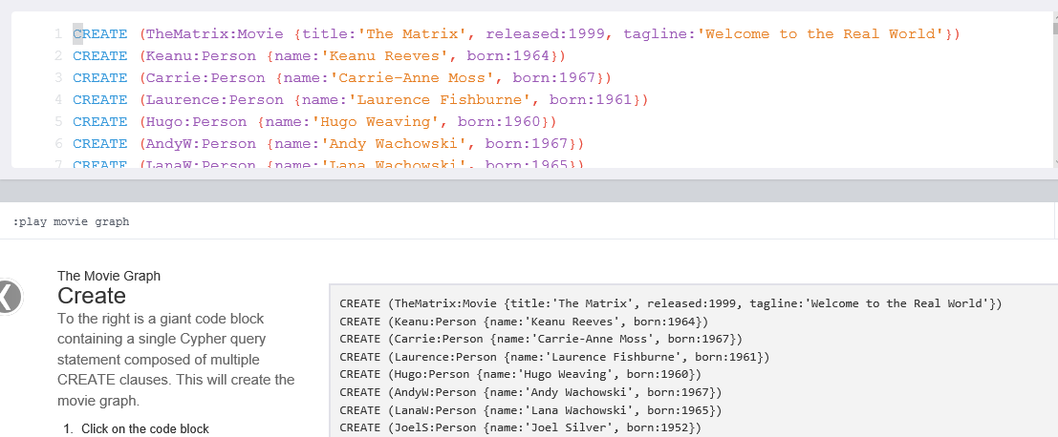

**4.Observations**

1)

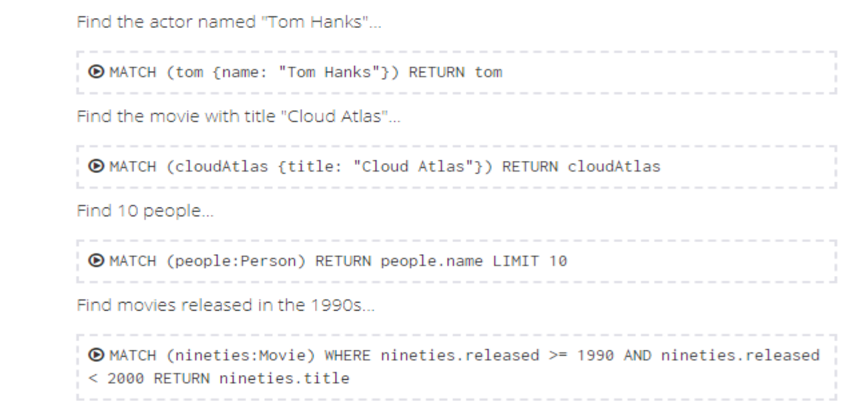

2)

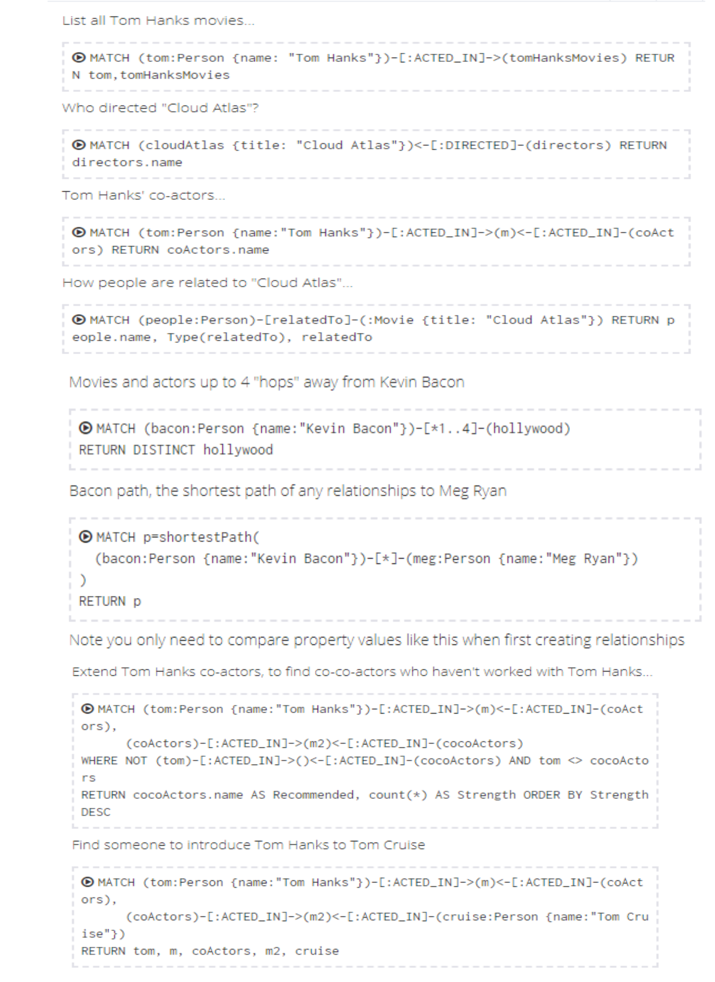

3)



4)



**5. Results:**

**Output of SET 1:**

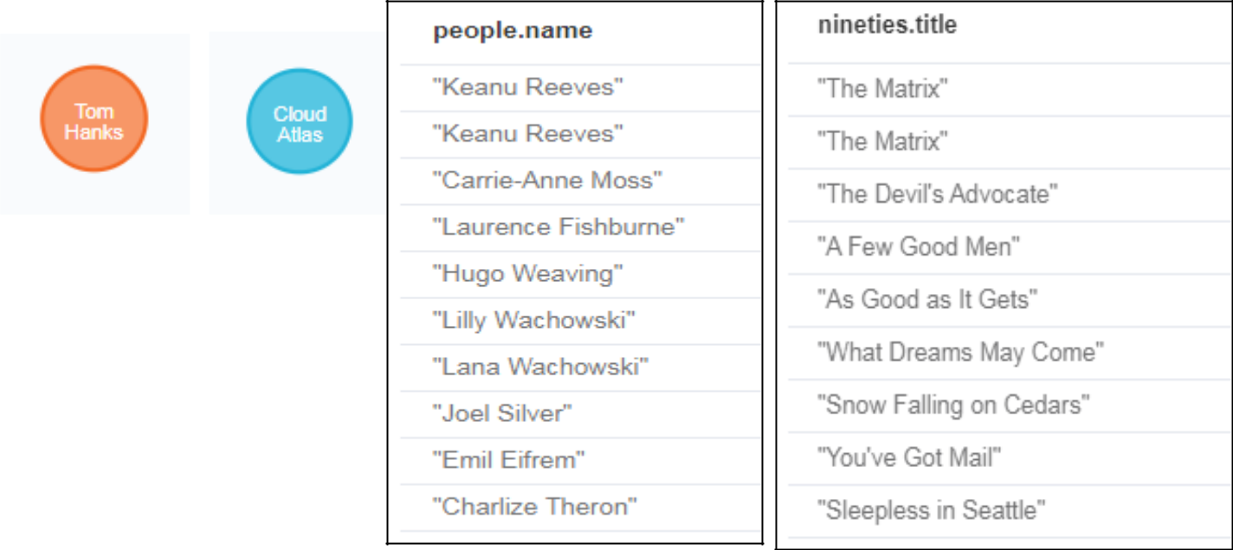

**Output of SET 2:**

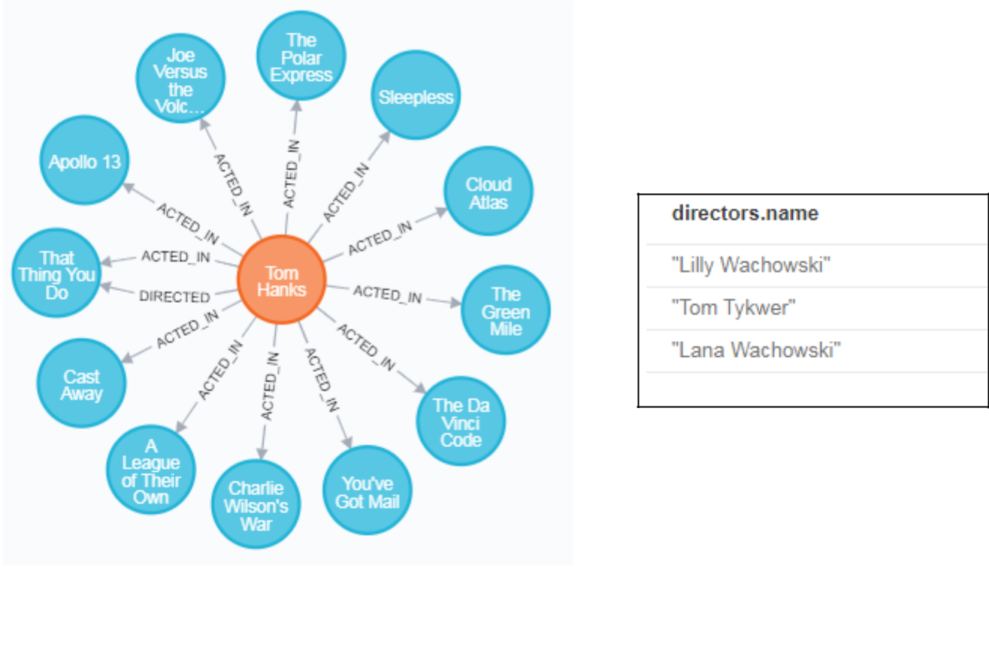

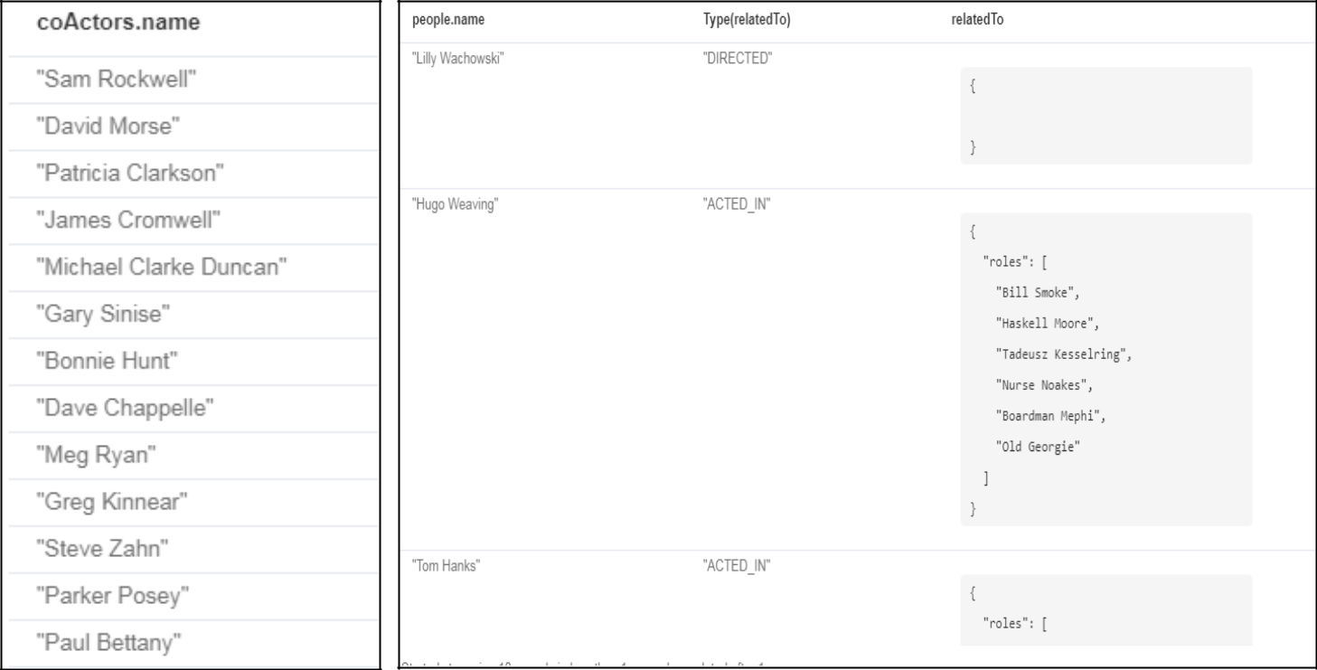

**Output of SET 3:**

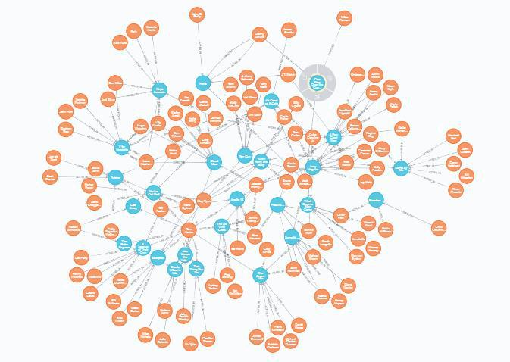

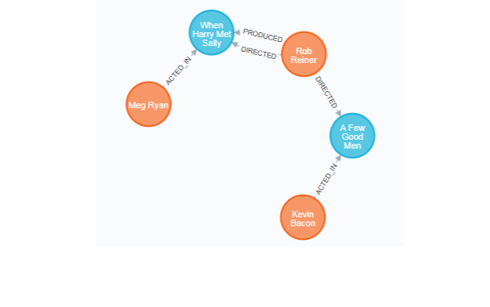

**Output of SET 4:**

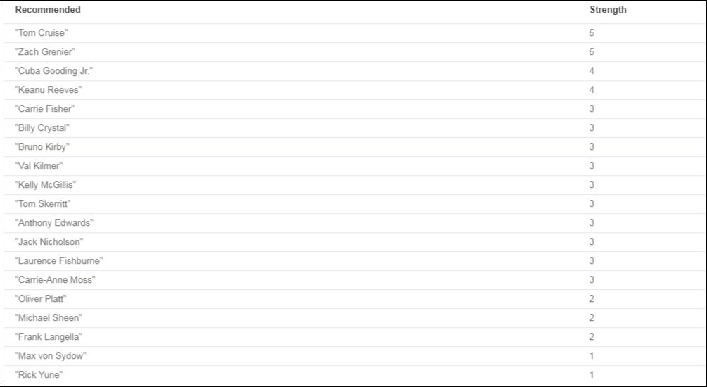 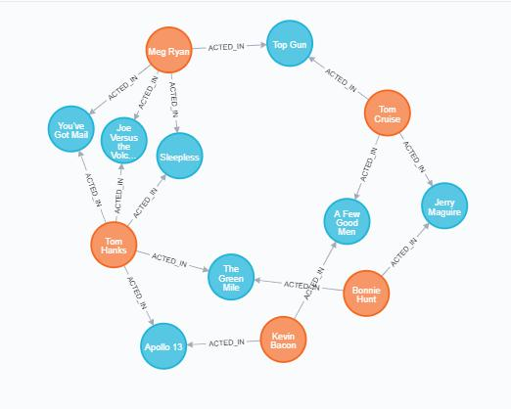

**8. References** :

[1] https://neo4j.com/developer/graph-database/

[2] http://whatis.techtarget.com/definition/graph-database